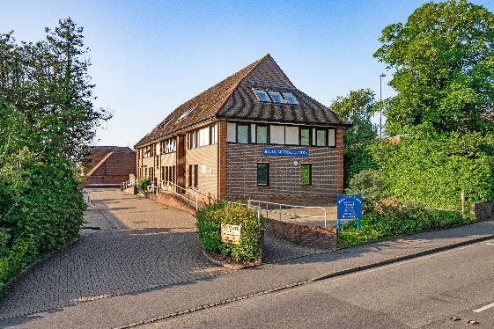BEACON SURGERY Bulletin

Welcome to our 6th quarterly bulletin. Keeping you up to date with the latest news from the Surgery and information relating to your health that may be of interest to you.

In this Issue:

**News from the Surgery**

A regular feature letting you know the latest news from the Surgery.

**Seasonal Health**

How we can help protect ourselves from the sun’s UV rays, avoid sun stroke and who should take extra care in the sun.

**Breast Screening**

Important advice on how to check your breasts and chest for signs of breast cancer.

___________________________

Surgery News

We have now completed repairs and a substantial refurbishment and upgrade to the lift. We are sorry it has been out of action for so long but parts had to be specially manufactured.

We always try to provide the best possible service to all of our patients although this sometimes can prove challenging at times of peak demand. This includes answering the questions that you raise with us. These can take a little time to respond to so please bear with us whilst we deal with them as promptly as we can. We will of course always treat you with respect and we just ask that you treat all of our staff in a similar manner.

Seasonal Health

The warm weather is now upon us. Sunburn increases your risk of skin cancer and does not just happen on holiday. You can burn in the UK, even when it is cloudy! There is no safe or healthy way to get a tan. Try to aim to strike a balance between protecting yourself from the sun and getting enough vitamin D from the sunlight. Here are some sun safety tips:-

* Spend time in the shade when the sun is strongest. In the UK, this is between 11am and 3pm from March to October.
* Never burn
* Cover up with suitable clothing and sunglasses
* Take extra care with children. Children aged under 6 months should be kept out of direct strong sunlight.
* Use at least factor 30 sunscreen which needs to be applied twice; apply 30 minutes before going out and again just before going out.

How to Deal with Sunburn

* Sponge sore skin with cool water, then apply soothing aftersun cream or spray, like aloe vera.
* Painkillers such as paracetamol or ibuprofen, will ease the pain by helping to reduce inflammation caused by sunburn.
* Stay out of the sun until all signs of redness have gone.
* Seek medical help if you feel unwell or the skin swells badly or blisters. Stay out of the sun until all signs of redness have gone.

Who Should Take Extra Care in the Sun?

You should take extra care in the sun if you:

* Have pale, white or light brown skin
* Have freckles or red or fair hair
* Tend to burn rather than tan
* Have many moles
* Have skin problems relating to medical conditions
* Are only exposed to intense sun occasionally (for example, while on holiday)
* Spend time in a hot country where the sun is particularly intense
* Have a family history of skin cancer

Breast Screening

As part of the NHS Breast Screening Programme, the Brighton, Hove & East Sussex breast screening service will be sending invitations to eligible women from all surgeries with timed appointments for screening. Our local breast screening location will be at Crowborough Memorial Hospital.

Anyone can get breast cancer. It is important to check your breasts or chest regularly (around once a month) for symptoms of breast cancer or other conditions.

What to look for when checking your breasts or chest:

* A lump or swelling in your breast, chest or armpit
* A change in the skin of your breast, such as dimpling (it may look like orange peel) or redness, which may be harder to see on black or brown skin
* A change in size or shape of 1 or both breasts, it’s common for breasts to be different sizes, but check for any changes that are not normal for you.
* Nipple discharge (if you are not pregnant or breastfeeding) which may have blood in it.
* A change in the shape or look of your nipple, such as it turning inwards (inverted nipples) or a rash on it (it may look like eczema).
* Sores or ulcers on your chest.

How to check your breasts and chest:

* Look at your breasts or chest in a mirror to look for any changes. Start with your arms by your sides and then raise them.
* Feel around each breast or side of your chest in a circular motion all the way up to your collarbone and under each armpit. Use a mix of light and firmer pressure. Do not press so hard it hurts.
* Feel around and over each nipple.

You may find it easier to feel your breasts or chest in the shower or lying down.